Myron Doc Downing PhD
Author | Therapist | Seminar Leader | BA, MSW, PhD

I Wish I Did Not Feel This Way
Three Ways to Change What You Feel

Have you ever had feelings that distress you? If you could wave a magic wand and change what you feel, would you do it? Which of your feelings would you change? “I wish I could change the way I feel about my parents.” “I hate my job. It is so boring, but the money and the benefits are outstanding.” “I wish I was not so hard on myself.”

“I wish I could find it in me to love that person after what they did.” “I wish I did not feel so anxious all the time.” “I have a hair-trigger temper that sometimes gets me into trouble.” “I wish I had more patience.” “I do not set boundaries because I am afraid of rejection and disapproval.”

Have any of you ever felt stressed, depressed, anxious, confused, frustrated, angry? It is within your power to change what you feel.

You feel the way you do right now
because of the thoughts you are thinking at this moment.
David Burns MD

You create your feelings! Since you create your feelings by what you are thinking at this moment, it is within your power to re-create them.

Four things you can learn about your feelings:
- How you are designed to operate.
- How you create your feelings.
- How you create the feelings you do not want.
- How to create the feelings you want.

What we know about thinking.
There are two different ways that we think. Research has led to insights that people think in either words and/or “pictures” (images, flashbacks, etc.). Deaf people will think in terms of sign language or pictures. Your preference of how you think, in words or pictures, indicates a bias in your thinking. Left-brain dominant people tend to think in words: right-brained dominant people tend to think more in imagery/pictures.
Thinking in “pictures” includes both negative and positive flashbacks. The feelings associated with an event can also be re-experience when triggered.
For example, visualize a picture/memory that was a very pleasant experience, like lying on a sandy dune and looking out to sea. Whenever you bring up those original “pictures” that were so pleasant the first time, you re-experience them again as pleasant. These visualized memories, positive or negative, can be triggered by a sound, a smell, a taste, something in your environment or they can also be re-experienced by guided imagery.
It all comes down to this: Something Happens you choose a meaning/interpretation, consciously or unconsciously, your interpretation/meaning determines your feelings then from the feelings that you are aware of, you choose a course of action (behavior). This is what it looks like if you draw it out.

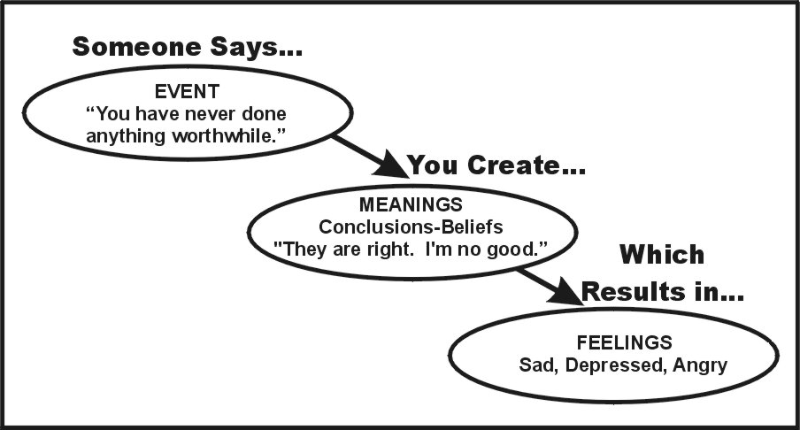

Your spouse divorces you (Event). You choose a meaning(s). Since you choose to think, and you can think anything you want to think/believe, that gives you numerous options to choose from:
- I failed. I am a no-good loser. (Blame yourself)
- It is my spouse’s fault; she had an affair. (Blame others)
- She belongs to me! If I cannot have her, no one else will. (Threats and control)
- I am a great spouse. He/she is just too blind to see i is t. (Rationalization)
- Nothing is a failure if I learn from it. (accept responsibility)
- I am going to dedicate myself to figuring out what went wrong so that I will not make the same mistake again. (Dedicate myself to growth and learning)
- None of the above (make up your own meaning).
When something happens, you will, consciously or unconsciously, put a meaning on it. While you cannot choose what happens to you, you and only you have the power to choose which meaning(s) you place on the event.
It has never been easier to change your feelings. This is not always been true. What we have learned (some people say relearned) in the last 60 years has made this all possible.

Feelings can be changed through:
1. A Cognitive Process. This is where you use the logical (left side) part of your brain. Here is a chart made by Matt Perlstein to help you put different meanings to the negative events that have happened.

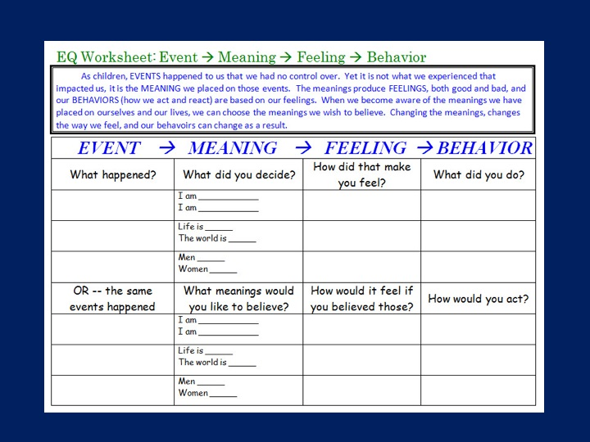
When using this chart, first make a list of all the feelings that you wish to change in yourself. Next, identify the events and then start filling out a separate chart for each event, choosing different meanings for each event.
Think of an event where you became incredibly angry. What about that event made you so angry? What was the belief you held at that time? Perhaps it was “People should do what I think they should do, not what they do.” Start looking for new beliefs. Then, start looking for new evidence to validate your new feelings.
When I was four years old, Mom and I rode the streetcar to downtown Sacramento. I had never seen so many people in one place. I watched very carefully and saw that at the intersections where there were policemen, when the policeman blew their whistle, the light changed color! For several years, the meaning I put on the policeman’s whistle was that it had magical powers.
As an adult, it is extremely important to re-evaluate your pictures, beliefs, values, and opinions on a regular basis for you still could be blowing your whistle and wondering why nothing is changing for you.
2. An Affective Therapy Process. Some therapists only use a cognitive approach. If you have been going to a therapist who only uses a cognitive approach and you feel stuck, you might consider switching to a therapist who uses right brain therapy techniques. This is where you use the emotional side of your brain. Your emotional side is often associated with flashbacks/pictures that can make you feel either stressed or relaxed.
You can expect an Affective Therapist to use several different affective techniques such as guided imagery, visualization, role-playing, Gestalt Dream Therapy, empty chair technique, postural induced affective metamorphosis, etc.
Since you cannot logically argue with a mental picture or flashback, the goal of these techniques is to change the pictures that are distressing you. This is done by placing a positive “picture” next to a “negative picture.” (+1-1=0) there has even been military medical experiments using LSD to help servicemen that are suffering with PTSD to replace the images that they see in their flashbacks.
3. A Behavioral Therapy Approach. A simple example of this is when a teacher gives a child an M&M for good behavior, or the boss gives out bonuses at the end of the year. Most of us have no problem with this kind of behavioral modification even though research has shown that it does not work particularly well as a long-term motivator.
The behavioral approach to therapy is most often associated with changing negative feelings such as anxiety and fear. Have you ever watched a small child at the top of a slide? The fear of falling is one of the two emotions that you were born with. The fear of falling is genetically in your DNA. How can you get over the fear of something you were born with? How does the parent help the child get over his fear of the slide?
You get to fear by doing what you are afraid to do.
Do you remember how you felt the first day going to a new job? Within the first few weeks your feelings changed completely! There was no more anxiety or worrying about the job. How did you change your feelings?
It has never been easier to change your feelings. This has not always been true. What we have learned (some people say relearned) in the last 60 years has made this all possible.
Do you see yourself as an introvert? Do you see yourself as being able to get up in front of a group of 500 people and talk to them? I had a young lady tell me that when she was in high school, she knew groups of people scared her. “So, I told all my teachers to assign me projects where I had to get up in front of the class and talk!” Today she is one of the top salespersons in her field, traveling all over the world speaking to groups of hundreds of people.

What you protect, you make weak!

Summary:
- You are in charge of what you think. You can think whatever you wish to think.
- You always putting meanings (beliefs, values, expectations) on whatever you see and/or experience.
- The meaning that you put on people, events, and words, determine what you feel about yourself, others, and the world.
- You can change your feelings only if you are aware of what you are thinking (meanings).
- There are three techniques that can help you change what you feel. These are your cognitive processes, your affective processes, and your behaviors.

In the graph below, look at the ovals marked Meanings. In the left oval, write down what you believe, think, conclude and your judgments that are causing your distressing feelings. In the right-hand oval, write down your beliefs conclusions and judgments that would give you the feelings that you would love to have.

Making charts like the one below and post them on your refrigerator. Then, every day, repeat the beliefs, values, expectations that you would like to have. Acknowledge, at the same time, that your negative beliefs do nothing for you but make you miserable.

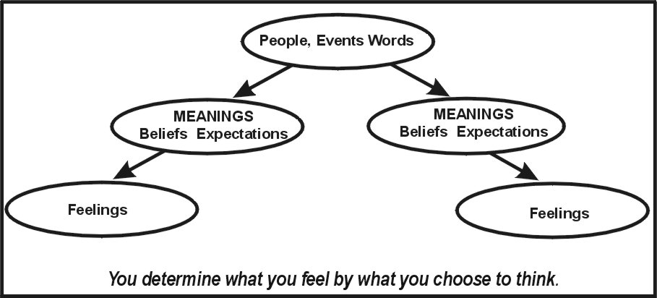

Important:
Once you figured out what meanings, beliefs, expectations you need to have to create the feelings you wish, then you need to watch for and validate events that support these new meanings.
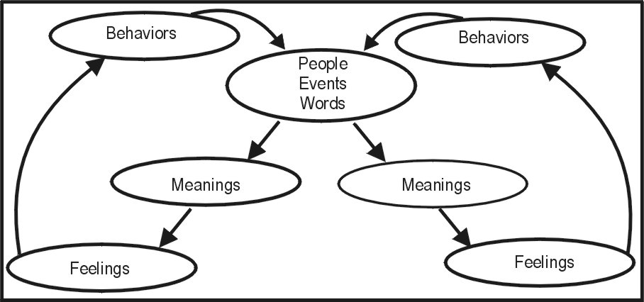
- If you do not like what you are feeling, change what you are thinking (Meanings, Beliefs, Expectations).
- The power is in your hands to change yourself.
- You are absolutely, totally, powerful to change yourself. You are absolutely, totally, powerless to change someone else.
You can contact Dr. Downing at:
Email: docdowning103@gmail.com
Joined Doc on Facebook

